OCEANA COUNTYJUNIOR MARKET
RABBIT RECORD BOOK – 2025
(for ages 5-7)

As a member of the Junior Market Animal Project, you are required to submit your records as part of an educational project notebook in order to show your animal at the Oceana County Fair. This notebook must be shown to the Rabbit Superintendent or designated Small Market Weighmaster at the time of weigh-in and then entered by you in the Educational Notebook Division at the Oceana County Fair on Entry Day.

NUMBER OF YEARS IN PROJECT: __________

AGE: __________

Your age you enter depends on how old you were on January 1, 2025.

Use this sheet as the first page of your project record book. Fill it out completely.

Please print or type neatly.

Name ____________________________________________________________

4-H Club Name ___________________________________________________

Breed, Variety and Age of Doe:

__________________________________________________________________
Breed Variety Age

Breed, Variety and Age of Buck used:

__________________________________________________________________
Breed Variety Age

Do you own the buck? ____ Yes _____ No

Date of Kindling: ________________________________________________

No. of live kits: ______________ No. of non-live kits: _____________

JUDGE’S SCORE/COMMENT SHEET

(PLEASE DO NOT REMOVE, PLACE THIS SHEET IN SHEET PROTECTOR OR GLUE TO COVER). This sheet must be keep free to the judge to write their comments.

This sheet should help each junior market member understand their ribbon placing.

A. Specific educational value or worth

___ All questions were answered completely

___ All calculations were correct

___ Calculations were incorrect

___ Questions were not completely answered

___ Questions were not answered (missed questions)

B. Notebook contains all project records

___ Notebook contained all project records and were fully completed

___ Notebook contained additional project related information (research

materials etc.)

___ Project records were incomplete

___There was no additional project related information

C. Accuracy, neatness and general appearance

___Notebook was neat in appearance (typed/hand printed)

___ Notebook pages were clean and stain free

___Notebook pages were in order and complete

___Notebook pages were out of order and missing pages

___Notebook was difficult to read and messy

___Notebook had wrinkled and stained pages

Other Comments: ____________________________________________________________

__________________________________________________________________

__________________________________________________________________
2025- JR Market Rabbit Notebook Page 2

OBJECTIVES
- Develop desirable work habits, sportsmanship, and ability to cooperate and express ideas through participation in projects, discussions, method demonstrations, judging teams, and exhibits.
- Experience the pride and responsibility of leasing/owning and caring for rabbits.
- Learn how to feed, fit, show, breed and raise rabbits.
- Learn proper handling procedures to prevent injuries to members and their rabbit projects.
- Appreciate and use scientific information in rabbit production and marketing.
- Improve knowledge of grading, marketing and merchandising of rabbits and rabbit products.
- Improve knowledge of the nutritive value of rabbit meat.
- Learn the importance of the rabbit industry to the local, state, and national economies.
- Acquire information on the opportunity that rabbits offer as a career.
This record book is part of your Junior Market Rabbit project. By keeping records up-to-date you will be able to see how much progress you make as you set goals and work to accomplish them. Write or type neatly and clearly. Please keep the pages in order. Feel free to add extra pages at the end of your notebook.

SCORING CRITERIA
The following breakdown will be used during the judging process of all market livestock notebooks.

A. Specific educational value or worth 30%
B. Creative way of showing what has been learned 10%
C. Notebooks contains all project records 50%
D. Accuracy, neatness and general appearance 10%

The Oceana County Oceana Agricultural Society encourages Leader and parent assistance with your project and project notebook.

If a parent or leader helped you in filling out your notebook please have them sign below that the answers are YOUR answers and that they assisted you in writing of the answers and understanding of the questions only.

_________________________________________________________
(Signature of person helping with notebook)

_________________________________________________________
(Printed name by member)
2025- JR Mkt Rabbit Notebook Page 3

About my Animal

My 4-H project animals is (species): ___________________________________________

My animals is a make or female? (check one)
- Male
- Female

My animal’s breed is: ** ______________________________________________________

My animal’s color(s) is: _______________________________________________________

The type of identification my animal has is: ____________________________________

What I like best about my animal project is: ___________________________________

______________________________________________________________________________

What I dislike most about my animal project is: ________________________________

______________________________________________________________________________

These are some of the things I learned by having an animal project: ____________

______________________________________________________________________________

______________________________________________________________________________

This is what I did t take care of my animal: _____________________________________

______________________________________________________________________________

______________________________________________________________________________

These are the people who helped me with my animal: _________________________

______________________________________________________________________________

Did you animal need to see a veterinarian? Yes or No (circle one)

If yes, why? ** ________________________________________________________________

** Denotes questions that are age appropriate for 7-8 year old members, although 5-6 year olds may respond.
2025- JR Mkt Rabbit Notebook Page 4

ANIMAL CARE AND MANAGEMENT

Your project requires regular care and management. List the things necessary to take care of your project animal(s).

Include the following:
- Feeding and watering practices
- Grooming (clipping, toenail trimming, etc.)
- Health practices and medicines
- General Management (cleaning cages/living area, etc.)

Daily- Things done once or twice a day
Weekly- Things done once or twice a week
Monthly- Things done once a month
Yearly- Things done one time or occasionally throughout the year
2025- JR Mkt Rabbit Notebook Page 5

COST OF YOUR PROJECT

INVENTORY- EQUIPMENT/SUPPLIES/MISCELLANEOUS
** have your parent, leader or an older teen in your club work with you to help you understand this portion of your notebook- expenses, etc. **

At the beginning of the project year take an inventory of what equipment & supplies are on hand.

Add new equipment or supplies you purchase to the list. Estimate a cost value for any shared equipment (ex: 1 set of nail clippers shared between 3 members $21.00÷3 = $7.00 each.)

Amount & Kind | Already Owned  Or Purchased | Purchase Price
Example: rabbit pen | Already Owned
1 feed bowl | Purchased | $3.00
Miscellaneous Expenses- if any (ex: breeding fees, cost of does, bucks, bunnies, medicines, etc.)
Example: 4 bunnies | Purchased | $40.00
 | Total (A) | $

2025- JR Market Rabbit Notebook Page 6

FEED RECORDS & EXPENSES

Keeping good feed records is important. Good records show your expenses for feed and what kind of feed you use for your project. A good practice is to enter your feed expenses when you buy feed. Home-raised feeds should be valued at market price- what it can be sold for.

Date of  Purchase | Amount Purchased (lbs.) | Cost  or  Value
TOTAL (B) | Lbs. | $

MISCELLANEOUS INCOME

List any income received. Examples: Selling additional offspring, fur, premiums
from shows, etc.) If none just write NONE.

Date | Description | Cost $
 | Total Miscellaneous Income (C) | $

Number of club meetings held: _________ Number I attended: ________

2025- JR Market Rabbit Notebook Page 7

AGE & WEIGHT CHART

Date of Weaning: _________________ Age at Time of Weaning: _______________

Weight at time of Weaning: Rabbit No. 1 ______________

Rabbit No. 2 ______________

Rabbit No. 3 ______________

Final Weight: Rabbit No. 1 ______________

Rabbit No. 2 ______________

Rabbit No. 3 ______________

Total Final Weight (FW) of Market Rabbit Pen: ______________

* Final weight may need to be estimated depending on Covid 19 restrictions summer of 2021.

PROJECT FINANCIAL SUMMARY

Grand Total of All Expenses (A+B): $ ___________________ (from pgs. 5 & 6)

Total Expenses – Any Income (C) = $ ___________________ (PE) Project Expense

________________ ÷ ________________ = ___________________________________
Project Expense (PE) Final Weight (FW) Break Even Price (BE)
(from above) (total cost per pound to raise your animal)

* Final weight may need to be estimated depending on Covid 19 restrictions summer of 2021.

** have your parent, leader or an older teen in your club help you figure out your breakeven price. The breakeven price is the price that you need to get at the Junior Market animal auction in order to not lose money on your market project. **

2025- JR Market Rabbit Notebook Page 8

COLOR THE PARTS OF THE RABBIT

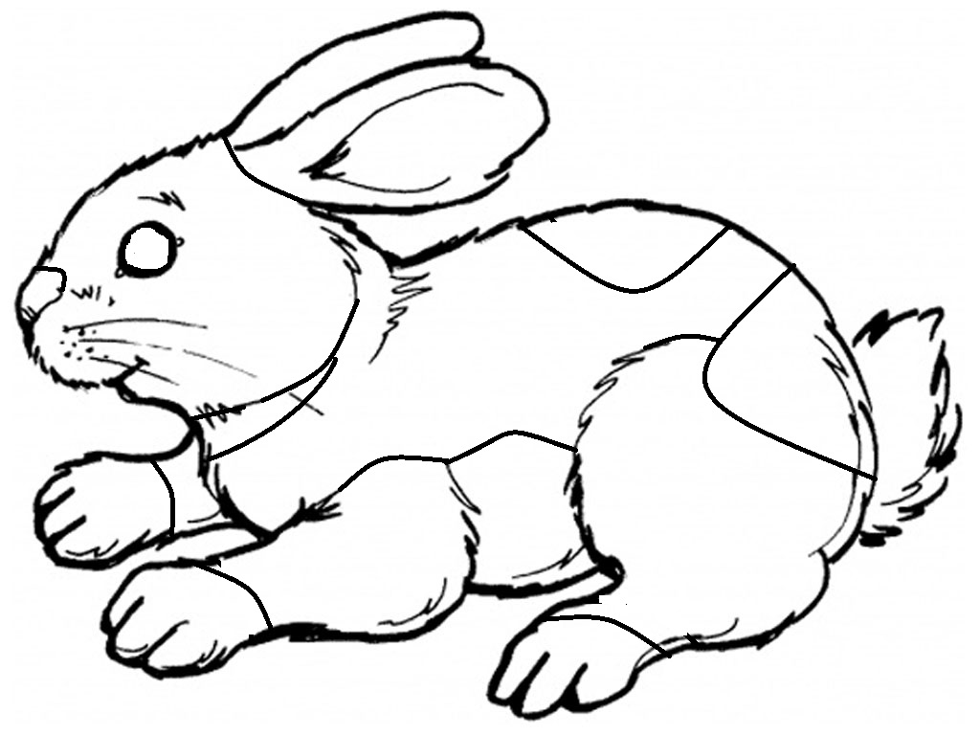

COLOR THE PARTS THE FOLLOWING

BELLY- ORANGE LOIN- GREEN TAIL- ORANGE

EARS- RED NECK- YELLOW TOES- BLUE

EYES- BLUE NOSE- PURPLE

LEGS- GREEN RUMP- RED

2025- JR Market Rabbit Notebook Page 9

What do you feed your 4-H animal?

______________________________________________________________________________

______________________________________________________________________________

______________________________________________________________________________

______________________________________________________________________________

Glue or tape a sample of your animal’s food/feed here:
(7–8-year-old member label each item)

2025- JR Market Rabbit Notebook Page 10

Use your senses to describe your animal.
Answers can be written or drawn.

How does it sound?
How does it look?

How does it feel?

What does it act like?
How does it smell?

2025-JR Market Rabbit Notebook Page 11

What did you learn by doing a 4-H animals projects?
What life skills did you focus on this year? Name the skills you learned about. Examples my include: sharing, teamwork, personal safety, goal setting, etc. Draw a picture or use words to describe what you learned.

Life Skill: __________________ Life Skill: _________________

Life Skill: __________________ Life Skill: _________________

2025-JR Market Rabbit Notebook Page 12

I Know 4-H

The 4-H’s
Can you list the four H’s of 4-H?
The 4-H Symbol
A green 4 leaf clover with a white “H” on each of its leaves. Draw a 4-H Clover!

Slogan

“Learn by Doing”
Motto

“To Make the Best Better”

Colors
What are the 4-H Colors?

______________________
This color represents springtime and nature’s most common color.

______________________
This color represents innocence and purity.
Pledge
Use the four H’s to complete the 4-H Pledge!
I pledge my ___________ to clearer thinking,
My ___________ to greater loyalty,
My ___________ to larger service, And my___________ to better living, for my club, my community, my country, and my world.
2025-JUNIOR MARKET RABBITS PAGE 13

POTENTIAL BUYERS NAMES

As part of your 4-H Small Market Livestock Project, you must personally contact at least three potential buyers before the Oceana County Fair. You are encouraged to seek two new buyers that have not been asked or submitted before. You also must have at least three different buyers than those of your siblings in the market livestock project. Please confirm with your buyers their accurate mailing address (example: post office box vs. a street address). The information on page 14 must be completed and taken to the Oceana County MSU Extension Office on or before the due date where it will be copied and used to send out letters to your potential buyers. This page will remain in your notebooks. This is a Market Livestock Committee rule. Failure to comply will result in not being able to sell your animal in the 4-H Market Livestock Sale.

2025-JR MARKET RABBITS Stamp _______________
PAGE 14 Staff _____
__________
JUNIOR MARKET/SMALL MARKET POTENTIAL BUYER’S LIST
RABBIT PROJECT (AGES 5-7)

Name______________________________ Club_________________________
Please print business names and complete addresses clearly.

  - Contact Name ____________________________________________________

Business Name ____________________________________________________

Mailing Address _________________________City_________________Zip_____

Phone _______________________ After Hours Phone______________________
Mailing Preference (Please Check One): Email ____ Postal Delivery ____

Email ____________________________________________________________

Signature__________________________________________________________

2. Contact Name ____________________________________________________

Business Name ____________________________________________________

Mailing Address _________________________City_________________Zip_____

Phone _______________________ After Hours Phone______________________
Mailing Preference (Please Check One): Email ____ Postal Delivery ____

Email ____________________________________________________________

Signature__________________________________________________________

3. Contact Name ____________________________________________________

Business Name ____________________________________________________

Mailing Address _________________________City_________________Zip_____

Phone _______________________ After Hours Phone______________________
Mailing Preference (Please Check One): Email ____ Postal Delivery ____

Email ____________________________________________________________

Signature__________________________________________________________

(Must be stamped by the MSU Extension Office)
2025- JR Market Rabbit Notebook Page 15

I’ll Tell You More!

Use this space to write, draw, or attach a photo. Are there more activities that you did with your animal that you would like to share? Is there more information that you’d like to share about you and your animal? What type of animal project would you like to do next year?

NON-CLUB POINTS- JUNIOR/SMALL MARKET PROJECT
(This must be filled out by participant before presenting for signatures at the MSUE office)
MEETING NAME | LOCATION | DATE | POINTS | SIGNATURE OF LEADER, SUPERINTENDENT OR MSU STAFF
Please note: This form must be included with your record notebook and turned into the weigh master on entry day of the Fair. BEFORE SEEKING SIGNATURES AT MSU EXTENSION – MEETING NAME AND DATE MUST BE COMPLETED You need to accumulate nine (9) points to be allowed to sell your animal. Six (6) of these nine (9) points must come from club meetings. The three (3) non-club points must be earned from attending various 4-H events and activities. See your leader, the MSUE office, or online at https://www.canr.msu.edu/oceana/oceana_county_4_h/oceana_4_h_market_livestock for a listing of approved nonclub points.
JUNIOR/SMALL MARKET PROJECT CLUB POINTS
(This must be filled out by participant before presenting for signatures at the MSUE office)
MEETING NAME | LOCATION | DATE | POINTS | SIGNATURE OF LEADER, SUPERINTENDENT OR MSU STAFF

Please note: This form must be included with your record notebook and turned into the weigh master on entry day of the Fair. You need to accumulate nine (9) points to be allowed to sell your animal. Six (6) of these nine (9) points must come from club meetings. The three (3) non-club points must be earned from attending various 4-H events and activities

